[***The Dictionary of Obscure Sorrows***](http://www.dictionaryofobscuresorrows.com/)

**Monachopsis:** The subtle but persistent feeling of being out of place.

* Feeling like you don’t belong (possibly despite others efforts of making you feel like part of the group)
* Could be at school or even within your own home
* Unaware of your surroundings
* Do not feel as though you are ‘home’
* Outside looking in, not necessarily physically but metaphorically
  + People are discussing past experiences that they have shared but you have not been there when they occurred

**Chrysalism**: The amniotic tranquility of being indoors during a thunderstorm.

* Womb-like
* Peaceful
* Calm
* Being safe within a building/home
* Thunderstorms
  + low rumbles
  + typically heavy rain sometimes hail
  + patterns that the rain make on the window
  + changes in contrast and saturation: images of thunderstorms are often backlit with muted colours
  + how does the rain affect different surfaces?
    - Grass becomes waterlogged, roads show reflections and appear ‘shiny’
    - Condensation on windows
  + how is nature affected?
    - Both human beings and animals seem scarce
    - Strong winds make leaves and trees move in a particular way
  + what sounds would be heard?
    - Rain drops hitting glass panes
    - Sound of leaves rustling in wind

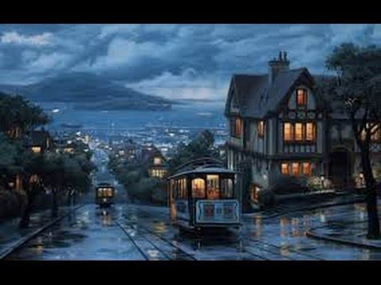

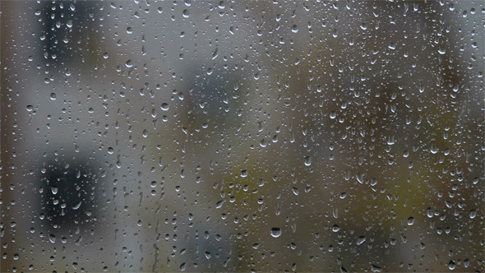

**Vemödalen**: The frustration of photographing something amazing when thousands of identical photos already exist.

* Being irritated as you are unable to alter the fact that your image is similar to many others in every detail despite initially thinking it was unique
  + Angle, lighting, subject matter, setting etc
* Fear of potential of being replaced or merging in with others
* Objects that evoke wonder and awe
  + Famous landmarks such as Big Ben or The Eiffel Tower
  + Images of animals and flowers

**Anecdoche**: A conversation in which everyone is talking but nobody is listening.

* People are not paying attention to what is being said
  + Will only be able to look and think about things up to a certain point and will never be able to delve beneath the surface of what has been mentioned
* Being unable to consider others opinions
* Talking over one another so that words are less distinct and merge into one

**Vellichor**: The strange wistfulness of ‘used book’ shops.

* Strange - unusual and unfamiliar, surprising or difficult to understand/explain
* Wistful - regretful, longing, nostalgic, melancholy (gloomy state of mind)
* The idea that books are filling the room and piling on the floor due to lack of shelf room
  + Chaos
  + Narrow hallways/walkways
  + Claustrophobic
* Smell of old leather bound books
* Full of history
  + Not just within the books but possibly within the architecture
* Mismatched or odd-looking furniture
* Buckling shelves
* Spiralling staircases which lead to curiosity
* An element of surprise 🡪 not knowing what you will find

**Adronitis**: Frustration with how long it takes to get to know someone.

* Almost like unfolding a mystery
  + May have to ask interesting ice breaker questions to make the other person feel comfortable
  + A degree honesty/trust involved
    - How do they know that they can trust you with potentially some of their darkest secrets
    - How do you know they are being 100% honest
* Could take weeks to find out answers to some of the simplest of questions and many months for the more complicated ones

**Rückkehrunruhe**: The feeling of returning home after an immersive trip only to find it fading rapidly from your awareness.

* Immersive 🡪 something that captured your attention fully so that you were completely involved in it
* May be other things happening that requires thought and consideration which make you forget about said trip
  + Have to try and remind yourself about the memories

**Occhiolism**: The awareness of the smallness of your perspective.

* Perspective 🡪 your viewpoint and the way you see things
* Small perspective
  + negative thinking?
  + Your size in comparison with other objects such as animals or buildings?

**Onism**: The frustration of being stuck in just one body that inhabits only one place at a time.

**Liberosis**: The desire to care less about things.

***Ideas***

**Occhiolism and Monachopsis**

**Monachopsis and anecdoche**

**Monachopsis and Rückkehrunruhe**

* A ghost character who is in the real world (can see and do things) but his actions cannot be seen or recognised by others
  + Monachopsis and anecdoche
* Astronaut goes to space/moon and on the way back he sees that a meteor has struck earth and wiped life off of the planet (cannot change his trajectory/route)
  + Rückkehrunruhe
* Time management ant farm game, or a game where you play as a small animal
* A game in which the character feels out of place in the real world and uses entertainment mediums to ‘escape’ to their ideal home
  + Occhiolism
* Some sort of dating simulation game, multiple choice answers to get to know someone
* Could be some sort of real-world tie so players have to wait a certain amount of time before being able to complete a task
  + Adronitis